QR Generator

Architecture Diagram:

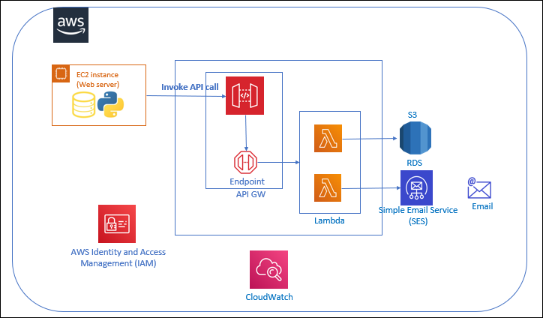

Project Description:

Application is developed over Django web framework. Application is hosted over EC2 server.

Application will integrate to backend system via API. API will be created & published using API GW.API GW will further forward request toward lambda.

AWS Lambda is a serverless, event-driven compute service that lets you run code for virtually communicate with database, log monitoring & SES for notification.

People now keep track of their favorite brands and products through their mobile devices, which is what makes QR Codes especially attractive for marketing. Targeted to mobile users, QR Codes are cost-effective, universally applicable, and help you reach your target audience in the offline world and connect them directly to your digital platforms.

Services Used:

**AWS API GW** – APIs act as the "front door" for applications to access data, business logic, or functionality from your backend services.

**AWS Lambda** - AWS Lambda is a serverless, event-driven compute service that lets you run code for virtually any type of application or backend service without provisioning or managing servers.

**AWS CloudWatch** - CloudWatch collects monitoring and operational data in the form of logs, metrics, and events.

**AWS SES** - Amazon Simple Email Service (SES) is a cost-effective, flexible, and scalable email service that enables to send mail from within any application.

**AWS IAM** - AWS Identity and Access Management (IAM) is a web service for securely controlling access to AWS resources.

**AWS RDS** - Amazon Relational Database Service (Amazon RDS) is a collection of managed services that makes it simple to set up, operate, and scale databases in the cloud.

**AWS EC2** - Amazon Elastic Compute Cloud (Amazon EC2) is a web service that provides secure, resizable compute capacity in the cloud.

**Django Framework** - Django is a high-level Python web framework that encourages rapid development and clean, pragmatic design.

AWS API GW:

Amazon API Gateway is a fully managed service that makes it easy for developers to create, publish, maintain, monitor, and secure APIs at any scale. APIs act as the "front door" for applications to access data, business logic, or functionality from your backend services. Using API Gateway, you can create RESTful APIs and WebSocket APIs that enable real-time two-way communication applications. API Gateway supports containerized and serverless workloads, as well as web applications.

API Gateway handles all the tasks involved in accepting and processing up to hundreds of thousands of concurrent API calls, including traffic management, CORS support, authorization and access control, throttling, monitoring, and API version management. API Gateway has no minimum fees or startup costs. You pay for the API calls you receive and the amount of data transferred out and, with the API Gateway tiered pricing model, you can reduce your cost as your API usage scales.

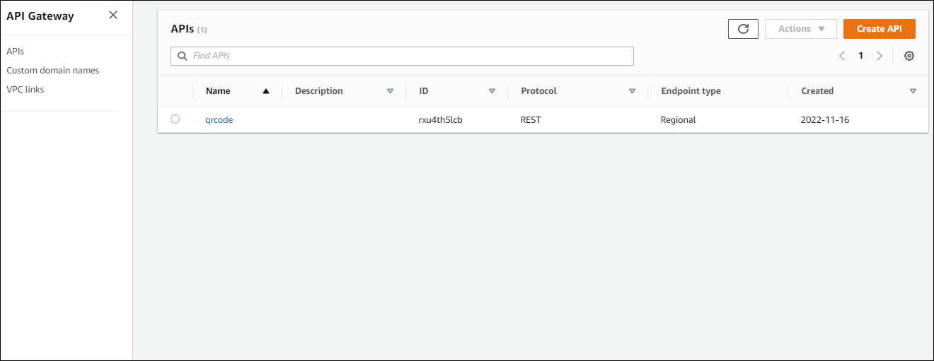

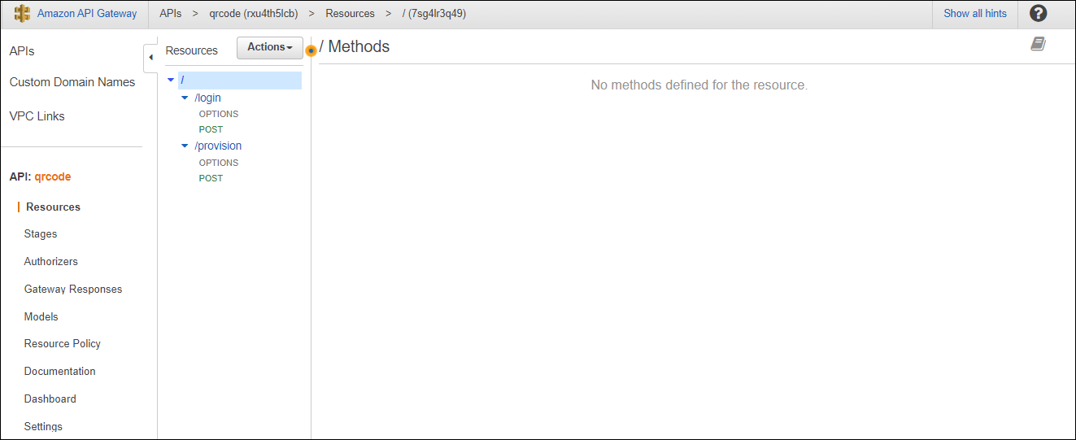

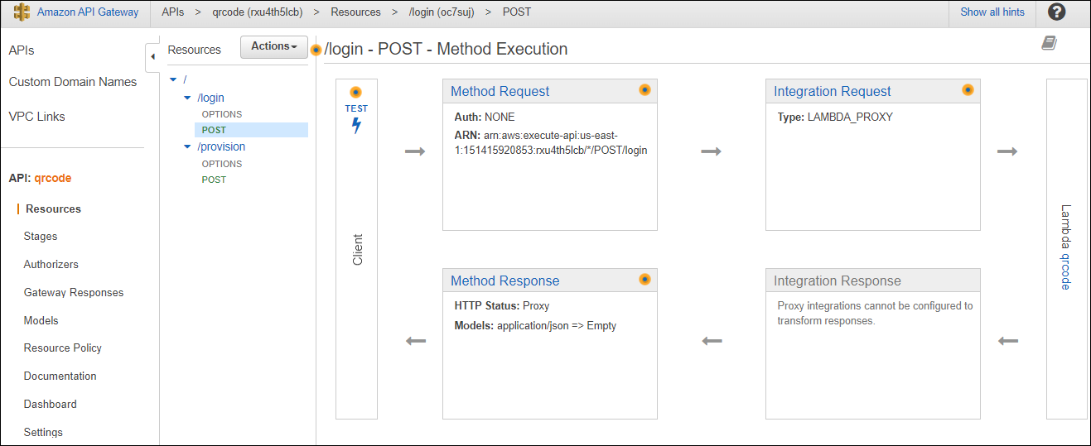

AWS Lambda:

AWS Lambda is a serverless, event-driven compute service that lets you run code for virtually any type of application or backend service without provisioning or managing servers.

Run code without provisioning or managing infrastructure. Simply write and upload code as a .zip file or container image.

Automatically respond to code execution requests at any scale, from a dozen events per day to hundreds of thousands per second.

Save costs by paying only for the compute time you use—by per-millisecond—instead of provisioning infrastructure upfront for peak capacity.

Optimize code execution time and performance with the right function memory size. Respond to high demand in double-digit milliseconds with Provisioned Concurrency.

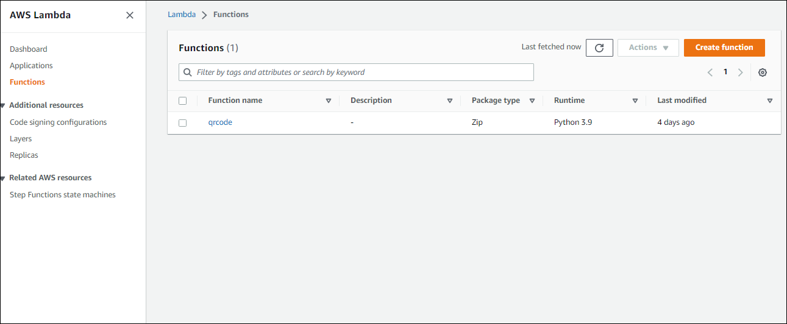

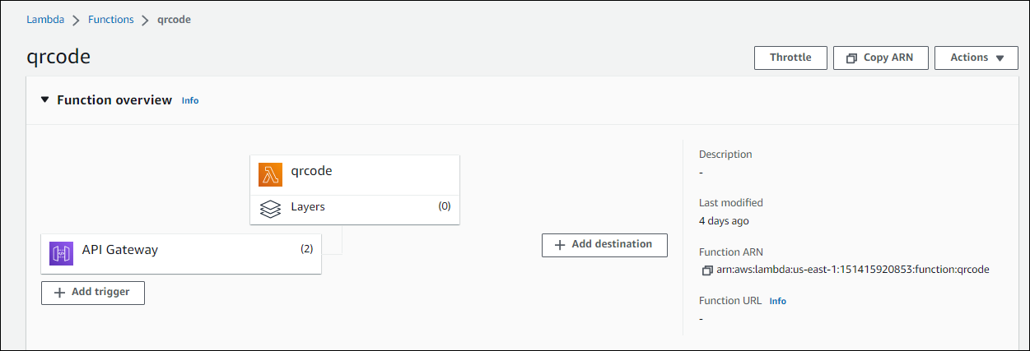

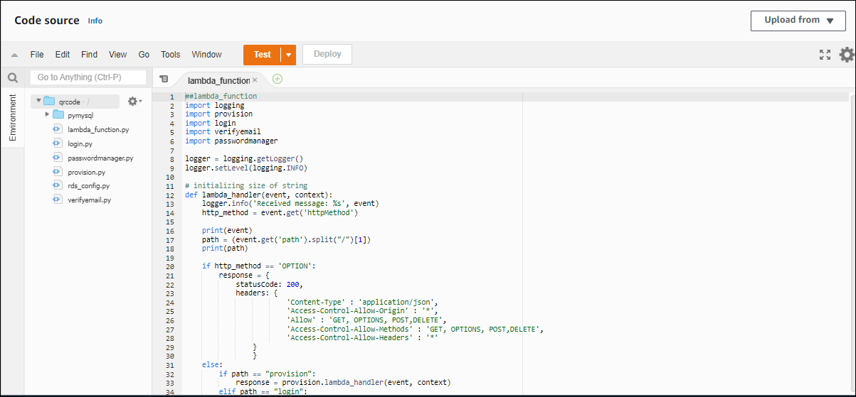

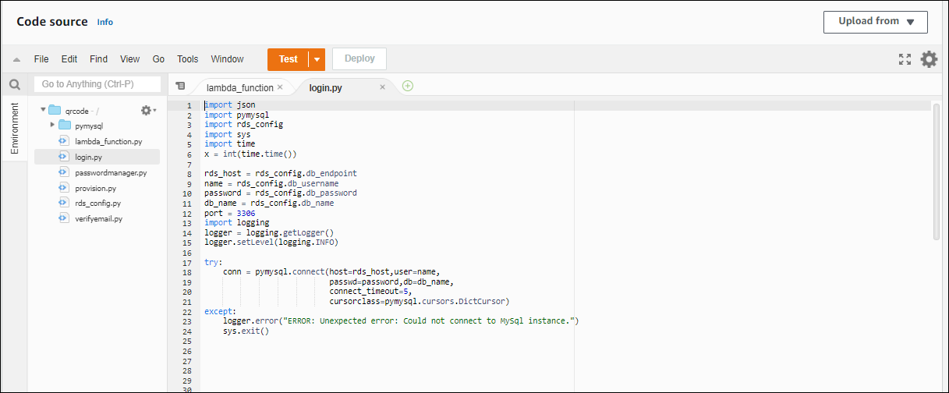

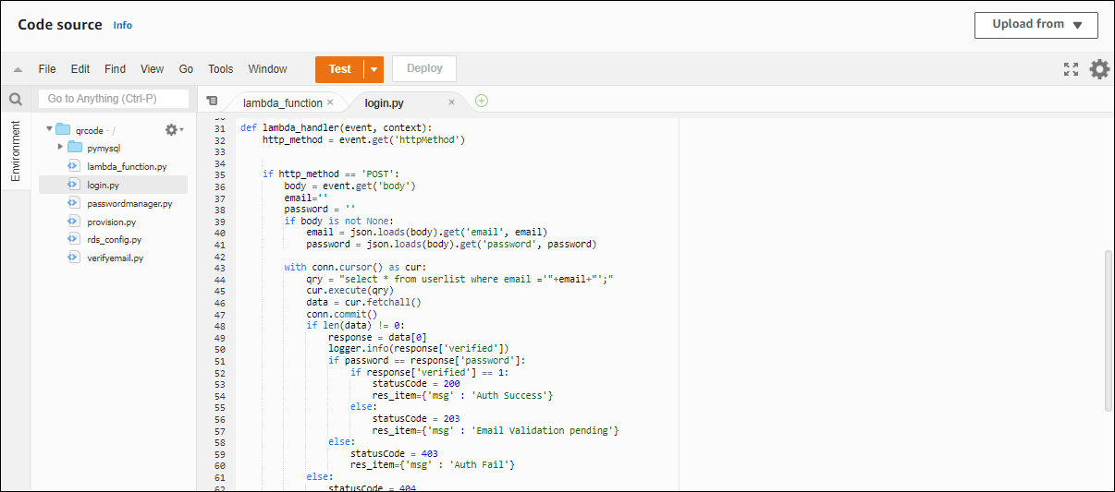

AWS CloudWatch:

Amazon CloudWatch is a monitoring and observability service built for DevOps engineers, developers, site reliability engineers (SREs), IT managers, and product owners.

CloudWatch provides you with data and actionable insights to monitor your applications, respond to system-wide performance changes, and optimize resource utilization.

CloudWatch collects monitoring and operational data in the form of logs, metrics, and events. You get a unified view of operational health and gain complete visibility of your AWS resources, applications, and services running on AWS and on-premises.

You can use CloudWatch to detect anomalous behavior in your environments, set alarms, visualize logs and metrics side by side, take automated actions, troubleshoot issues, and discover insights to keep your applications running smoothly.

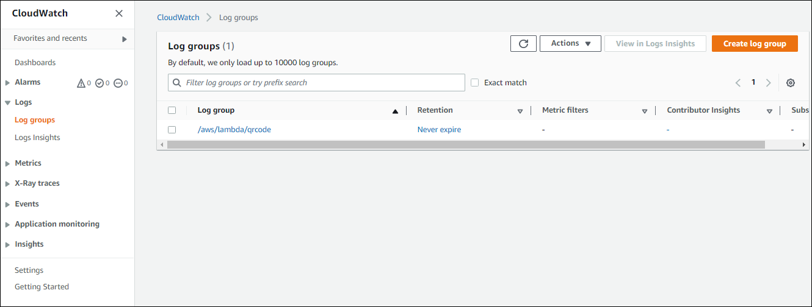

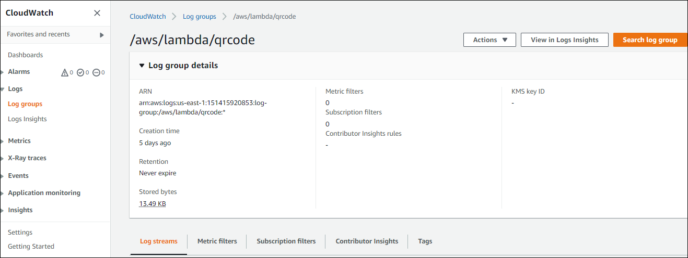

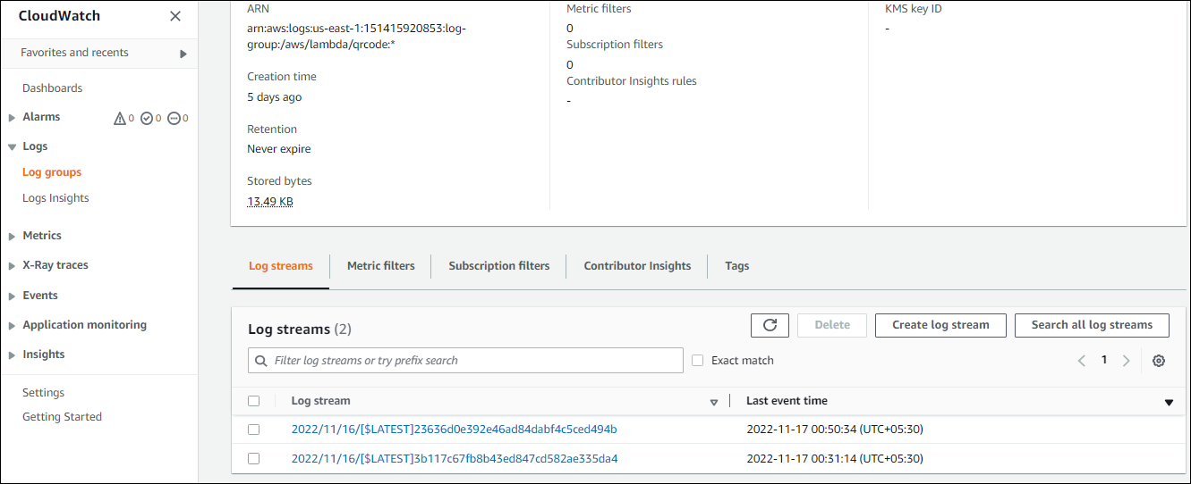

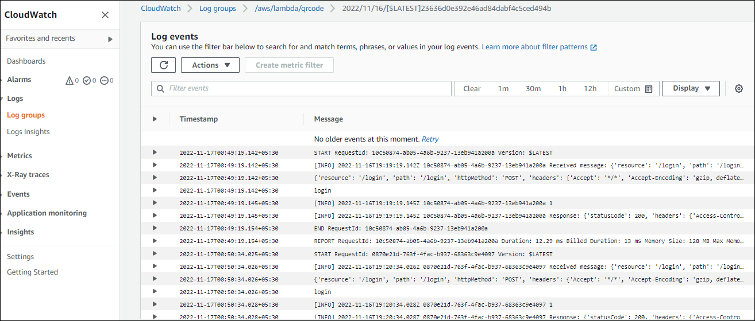

AWS SES:

Amazon Simple Email Service (SES) is a cost-effective, flexible, and scalable email service that enables developers to send mail from within any application. You can configure Amazon SES quickly to support several email uses cases, including transactional, marketing, or mass email communications. Amazon SES's flexible IP deployment and email authentication options help drive higher deliverability and protect sender reputation, while sending analytics measure the impact of each email. With Amazon SES, you can send email securely, globally, and at scale.

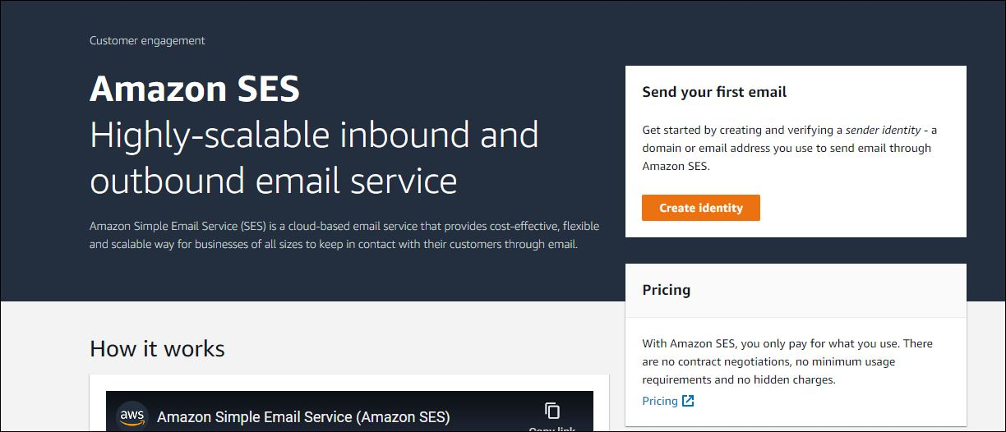

AWS IAM:

AWS Identity and Access Management (IAM) is a web service for securely controlling access to AWS resources.

The IAM workflow includes the following six elements:

A principal is an entity that can perform actions on an AWS resource. A user, a role or an application can be a principal.

Authentication is the process of confirming the identity of the principal trying to access an AWS product. The principal must provide its credentials or required keys for authentication.

Request: A principal sends a request to AWS specifying the action and which resource should perform it.

Authorization: By default, all resources are denied. IAM authorizes a request only if all parts of the request are allowed by a matching policy. After authenticating and authorizing the request, AWS approves the action.

Actions are used to view, create, edit or delete a resource.

Resources: A set of actions can be performed on a resource related to your AWS account.

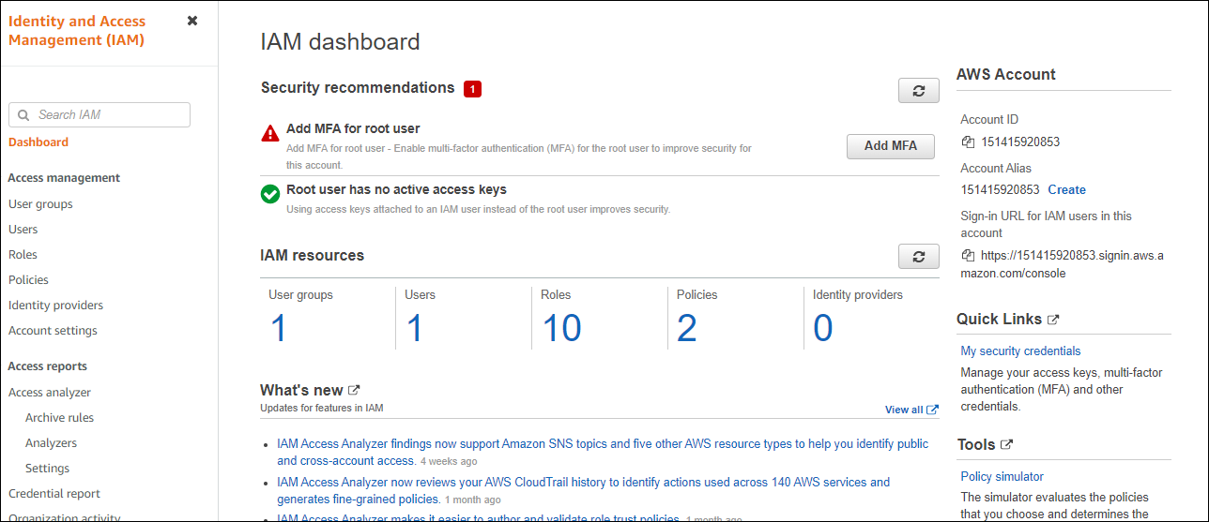

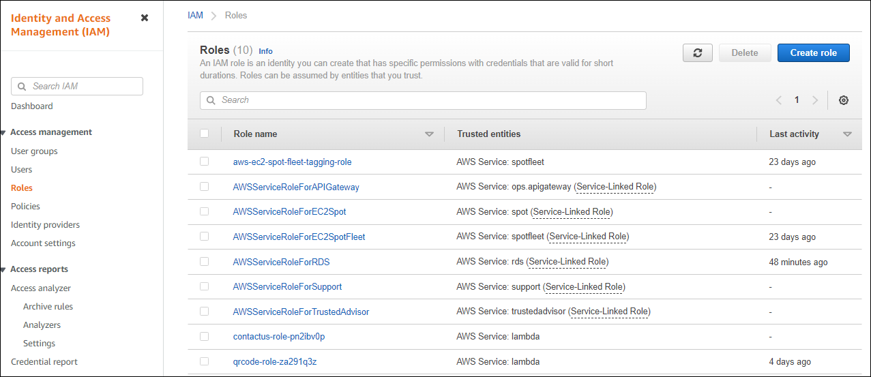

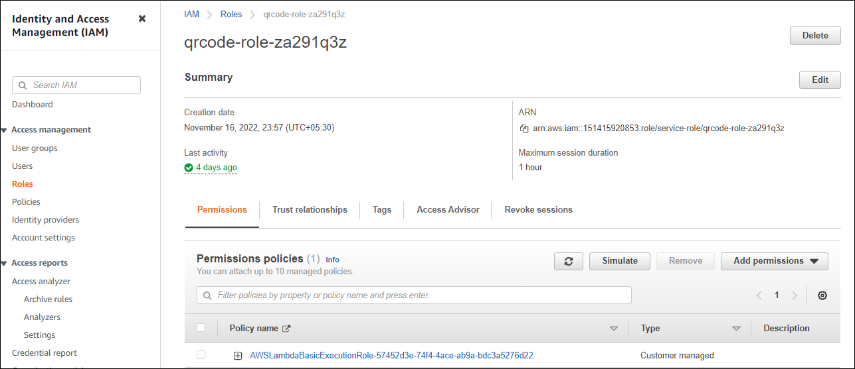

AWS RDS:

Amazon Relational Database Service (Amazon RDS) is a web service that makes it easier to set up, operate, and scale a relational database in the cloud.

Amazon RDS minimizes relational database management by automation.

Amazon RDS creates multiple instances for high availability and failovers.

Amazon RDS supports PostgreSQL, MySQL, Maria DB, Oracle, SQL Server, and Amazon Aurora.

Amazon RDS stores data as tables, records, and fields.

Values from one table can have a relationship to values in other tables. Relationships are a key part of relational databases.

Relational databases are often used for storing transactional and analytical data.

Relational databases provide stability and reliability for transactional databases.

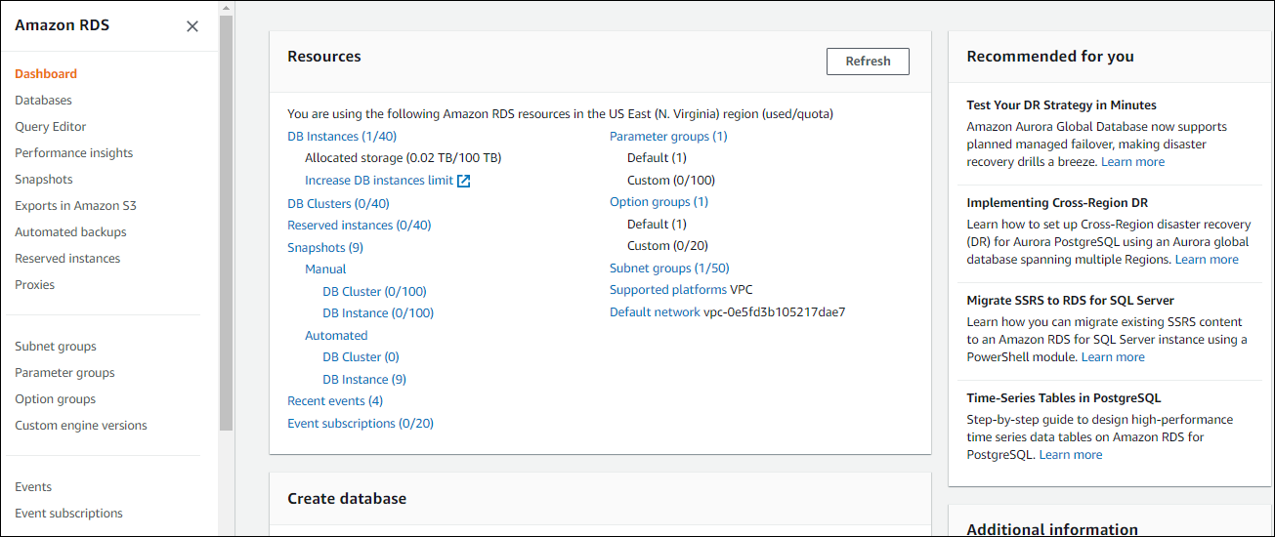

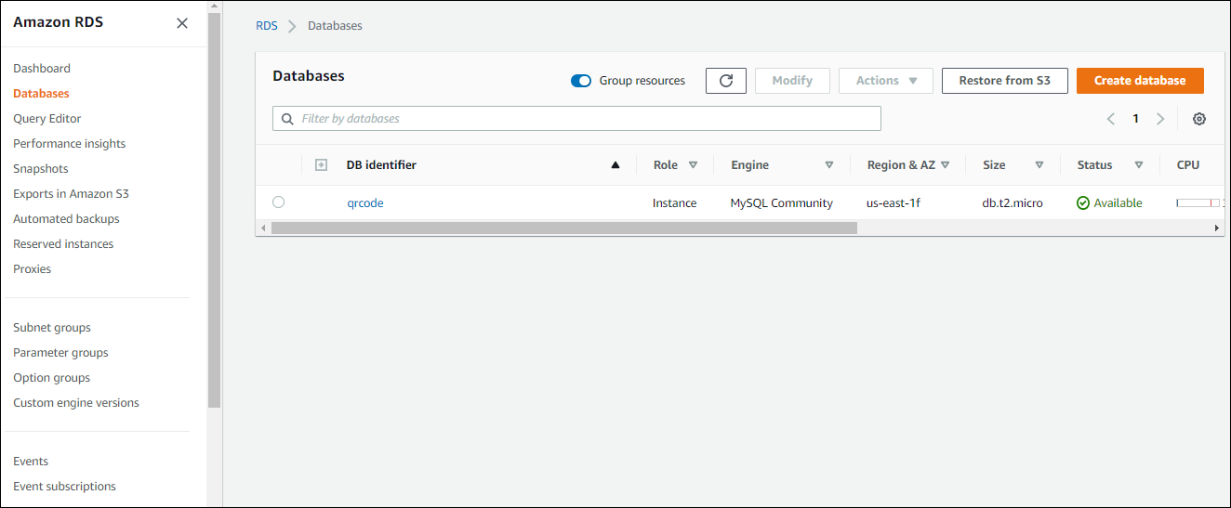

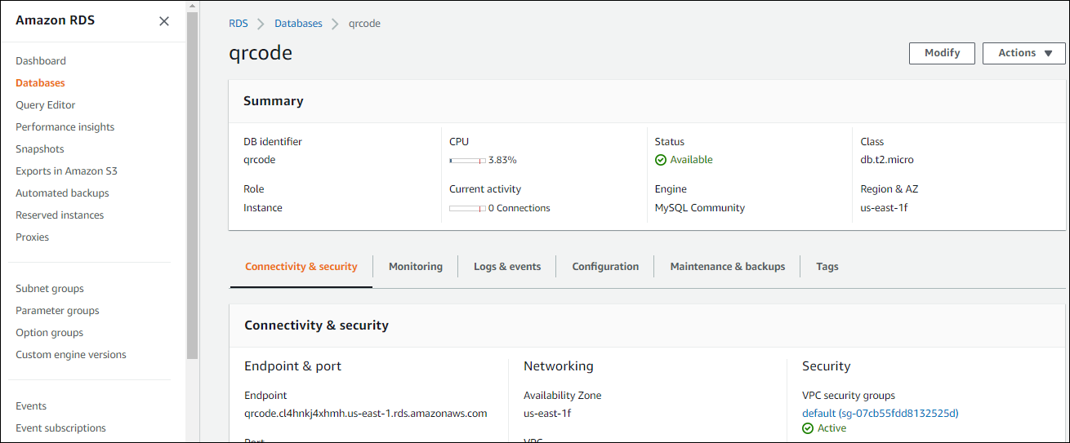

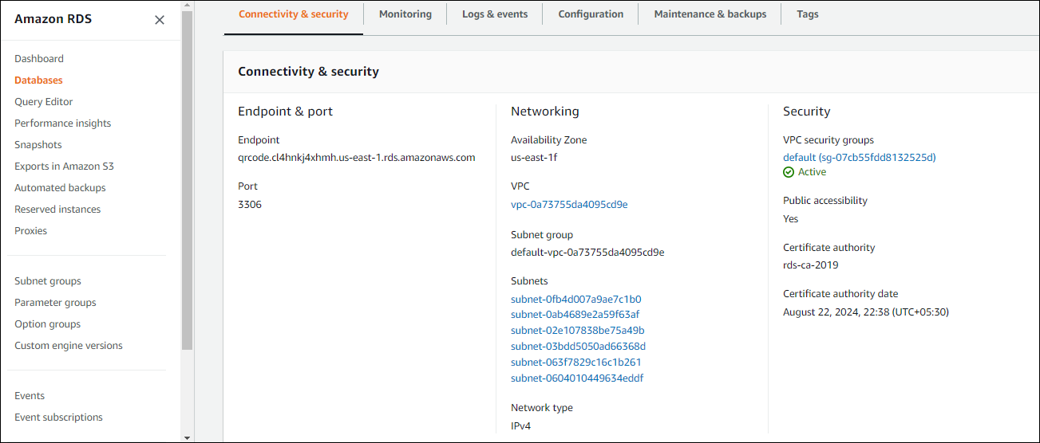

AWS EC2:

Amazon Elastic Compute Cloud (Amazon EC2) is a web service that provides secure, resizable compute capacity in the cloud. It is designed to make web-scale cloud computing easier for developers. Amazon EC2’s simple web service interface allows you to obtain and configure capacity with minimal friction. It provides you with complete control of your computing resources and lets you run on Amazon’s proven computing environment.

Amazon EC2 offers the broadest and deepest compute platform with choice of processor, storage, networking, operating system, and purchase model. We offer the fastest processors in the cloud and we are the only cloud with 400 Gbps ethernet networking. We have the most powerful GPU instances for machine learning training and graphics workloads, as well as the lowest cost-per-inference instances in the cloud. More SAP, HPC, Machine Learning, and Windows workloads run on AWS than any other cloud.

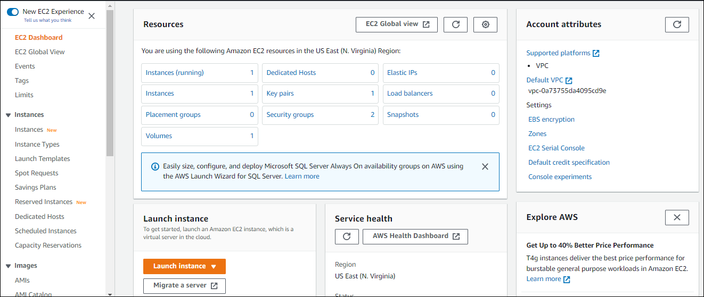

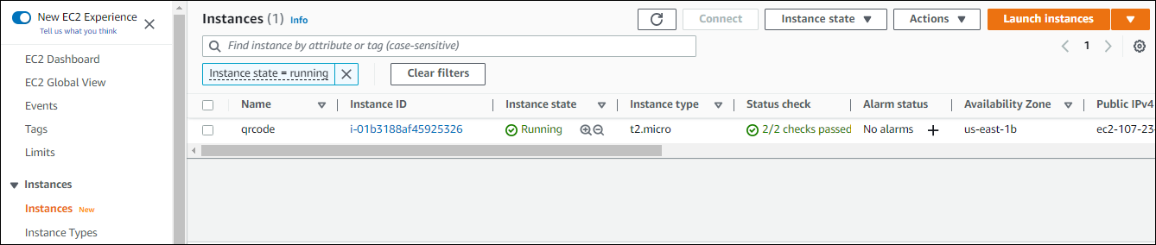

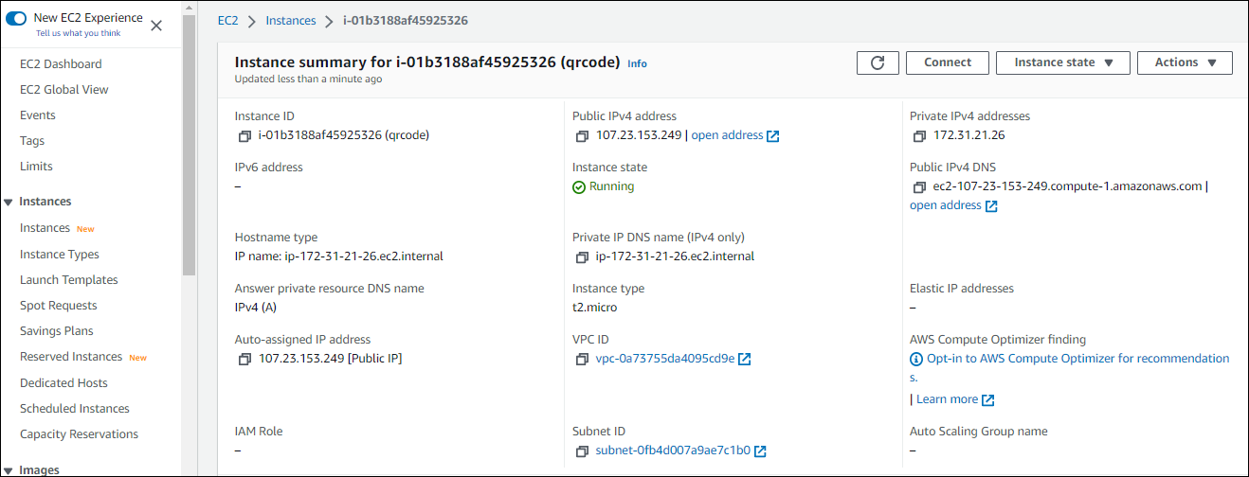

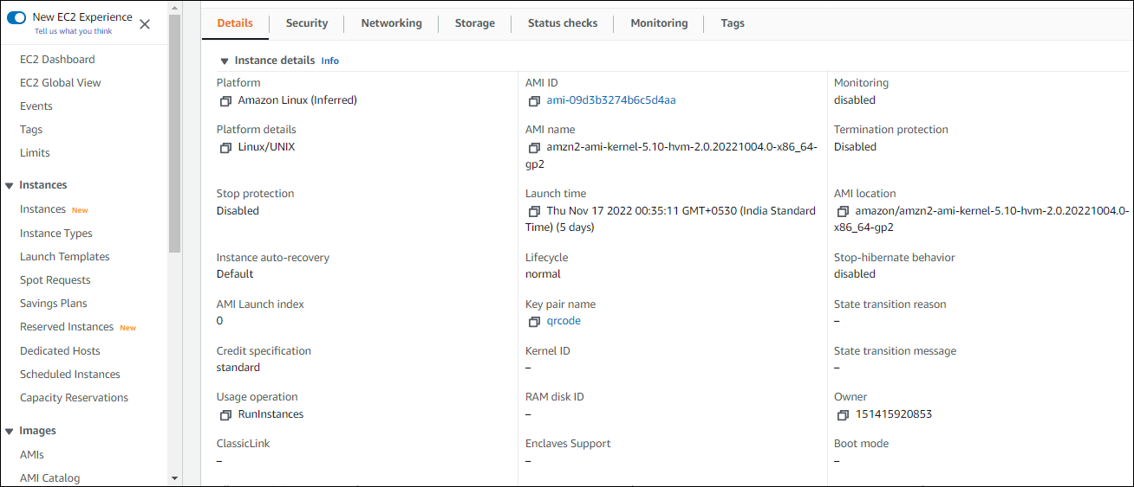

Django (Python Web Framework):

Django is a high-level Python web framework that encourages rapid development and clean, pragmatic design. Built by experienced developers, it takes care of much of the hassle of web development, so you can focus on writing your app without needing to reinvent the wheel. It’s free and open source.

Ridiculously fast.

Django was designed to help developers take applications from concept to completion as quickly as possible.

Reassuringly secure.

Django takes security seriously and helps developers avoid many common security mistakes.

Exceedingly scalable.

Some of the busiest sites on the web leverage Django’s ability to quickly and flexibly scale.

User Interface:

